**Assignment #6**

**Stats 157 Winter 2018**

Sarah Ruckman

SID: 7194

Suppose you are a veterinarian and have been asked to participate in a national project concerning dogs and the presence/absence of microchips and spaying and neutering. Suppose data has been entered in hundreds of Excel files such as the two Excel files being used in this assignment.

1. Write a SAS macro (or modify an existing macro) called indata1 to read in and print out the data in each of the Excel files. (Done as part of Assignment #5)

**SAS Code:**

/*Set up format for the output*/

options ls = **78** ps = **55** nodate nonumber nocenter mtrace mlogic mprint;

ods graphics off;

/*

*******************************************************************

macro heading1 macro to generate titles

Parameters

what parameter to identify what object

number1 number of the object

quarter1 quarter and year

filenum which data file (1 or 2)

*******************************************************************

*/

**%macro** heading1(what,number1,quarter1);

title1 "Statistics 157 &quarter1";

title2 "&what &number1";

title3 "Sarah Ruckman";

%*Close the macro;

**%mend** heading1;

/* ******************************************************************

macro importing

USAGE: to read in Excel files

Variables:

start sheet number to start

stop sheet number to stop

name1 base name of the worksheets

name2 name to add on for new SAS dataset

filename name and path to Excel file to be read in

******************************************************************* */

**%macro** indata1(start,stop,name1,name2,filename);

%*Setup macro do loop to read in series of worksheets;

%do i = &start %to &stop;

%* Use proc import to import the excel file;

PROC IMPORT OUT = WORK.&name1&i

DATAFILE= "&filename&i..xls"

DBMS=xls REPLACE;

SHEET="&name1&i";

GETNAMES=YES;

%*Create new SAS temporary dataset;

data &name1&i&name2;

%* Format %heading1(what,number1,quarter1,&i);

%***heading1***(Assignment,**6**,Winter **2018**);

%*Use set command to get information from output file;

set &name1&i;

%*Print the data as check;

proc print noobs;

%*Close the marco do loop;

%end;

%*Close the macro;

**%mend** indata1;

/*Execute the macro

Format %indata1(start,stop,name1,name2,filename_including_path)

Be sure you change the path to your file*/

%***indata1***(**1**,**2**,dog,b,C:\Users\sarah\Downloads\dogs_w18);

**run**;

**quit**;

**Output:**

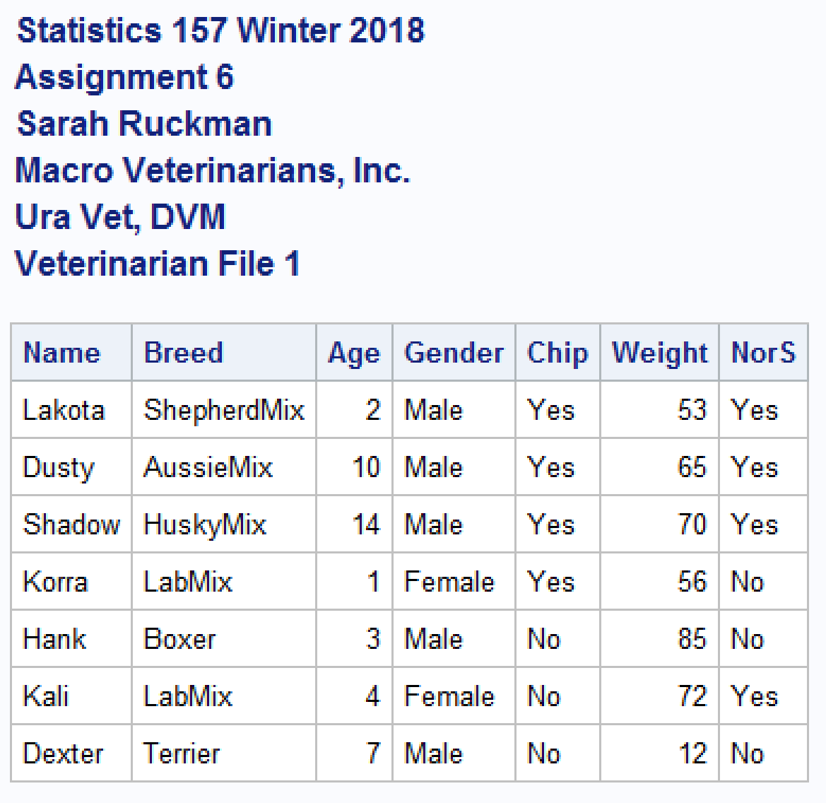



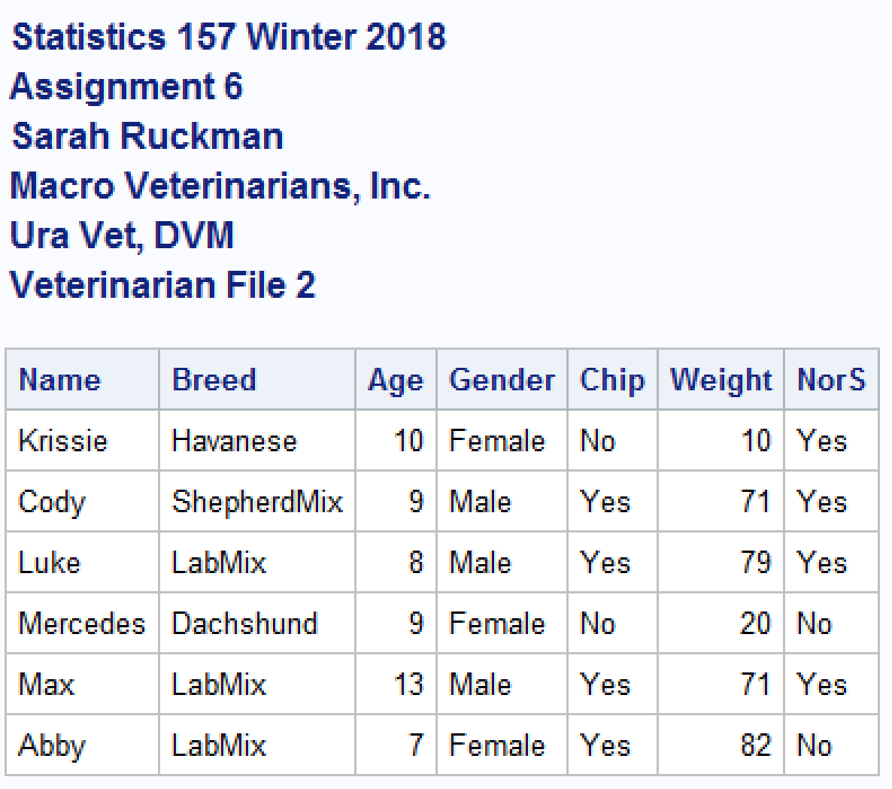



1. Write a SAS macro called heading1 to read in the following headings: (3 pts)

MACRO VETERINARIANS, INC.

Ura Vet, DVM

Veterinarian File XX (where XX is the number of the file - 1 for dogs_w181.xls 2 for dogs_w182.xls )

These titles should be in addition to the usual titles. Thus they should be titles 4, 5 and 6. (You may include the original titles in this macro!)

**SAS Code:**

/*

*******************************************************************

macro heading1 macro to generate titles

Parameters

what parameter to identify what object

number1 number of the object

quarter1 quarter and year

filenum which data file (1 or 2)

*******************************************************************

*/

**%macro** heading1(what,number1,quarter1,filenum);

title1 "Statistics 157 &quarter1";

title2 "&what &number1";

title3 "Sarah Ruckman";

title4 "Macro Veterinarians, Inc.";

title5 "Ura Vet, DVM";

title6 "Veterinarian File &filenum";

%*Close the macro;

**%mend** heading1;

**ADDED NEXT LINES AFTER DATA STEP in indata1 macro:**

%* Format %heading1(what,number1,quarter1,&i);

%***heading1***(Assignment,**6**,Winter **2018**,&i);

**Output:**





1. NEW (5 pts) Write a SAS macro called sizing to determine the size of each dog, according to the following limits:

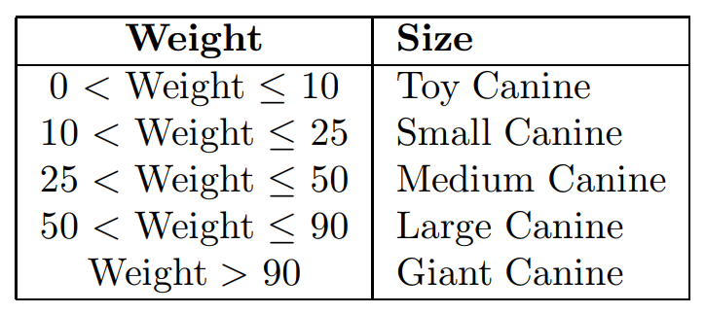

**SAS Code:**

**Added after heading1 macro:**

/********************************************************************

Macro sizing to classify each dog according to size

Variable specifications:

size name of size variable

********************************************************************/

**%macro** ***sizing***;

%* Use if then else structure to classify size;

if Weight <= **10** then size = 'Toy Canine ';

else if **10** < Weight <= **25** then size = 'Small Canine ';

else if **25** < Weight <= **50** then size = 'Medium Canine';

else if **50** < Weight <= **90** then size = 'Large Canine ';

else size = 'Giant Canine ';

%*Close the macro;

**%mend** sizing;

**Added to indata1 macro after set command:**

%* Classify dogs according to size;

%***sizing***;

**Output:**

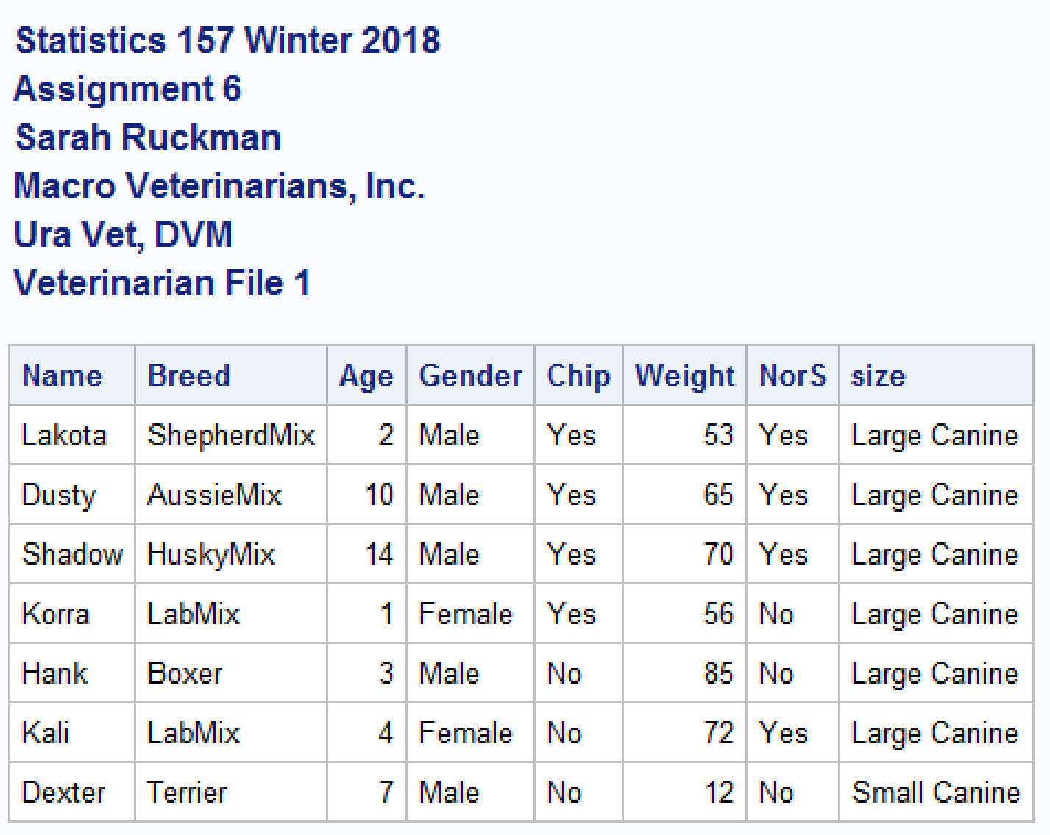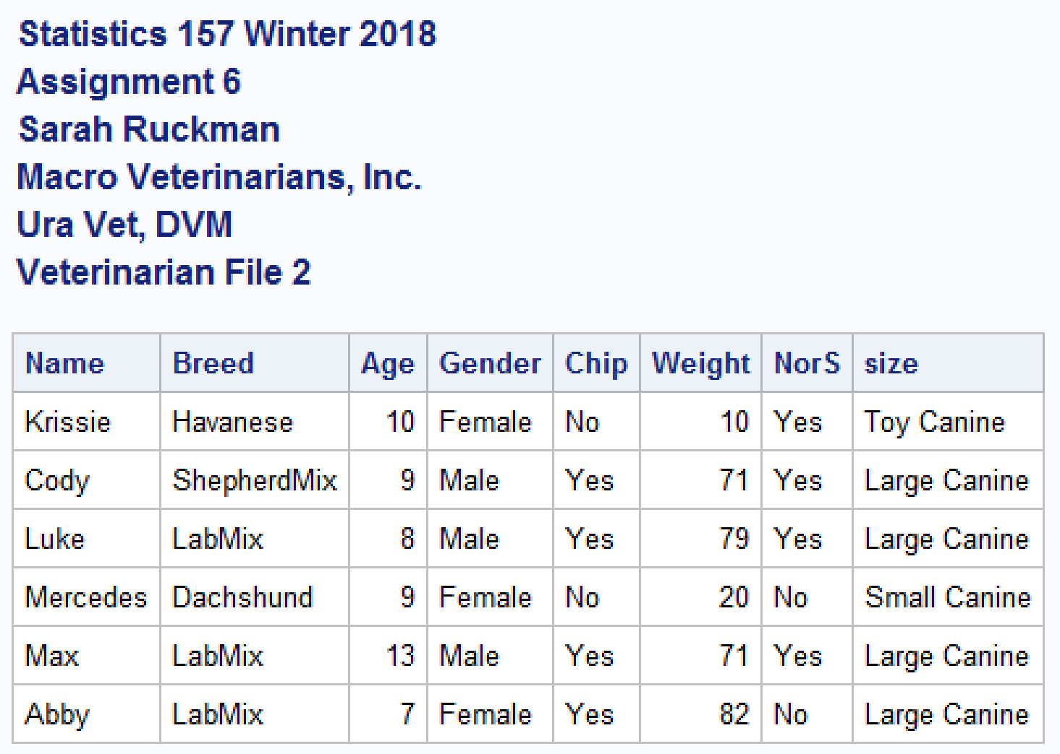

1. NEW (5 pts) Write a SAS macro called ageclass to determine the age class of each dog, according to the following limits: (Guidelines from Eukanuba & Iams)

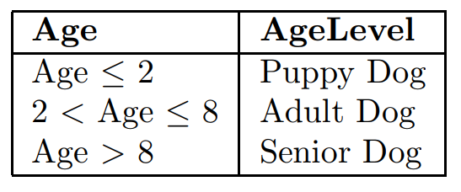

**SAS Code:**

**Added after sizing macro:**

/********************************************************************

Macro ageclass macro to classify an animal according to age

Variable Specification:

agelevel name of age class variable

********************************************************************/

**%macro** ***ageclass***;

%* Use if then else structure to classify age;

if age <= **2** then agelevel = 'Puppy Dog ';

else if **2** < age <= **8** then agelevel = 'Adult Dog ';

else agelevel = 'Senior Dog';

%*Close the macro;

**%mend** ageclass;

**Added after sizing in indata macro:**

%*CLassify dogs according to age;

%***ageclass***;

**Output:**

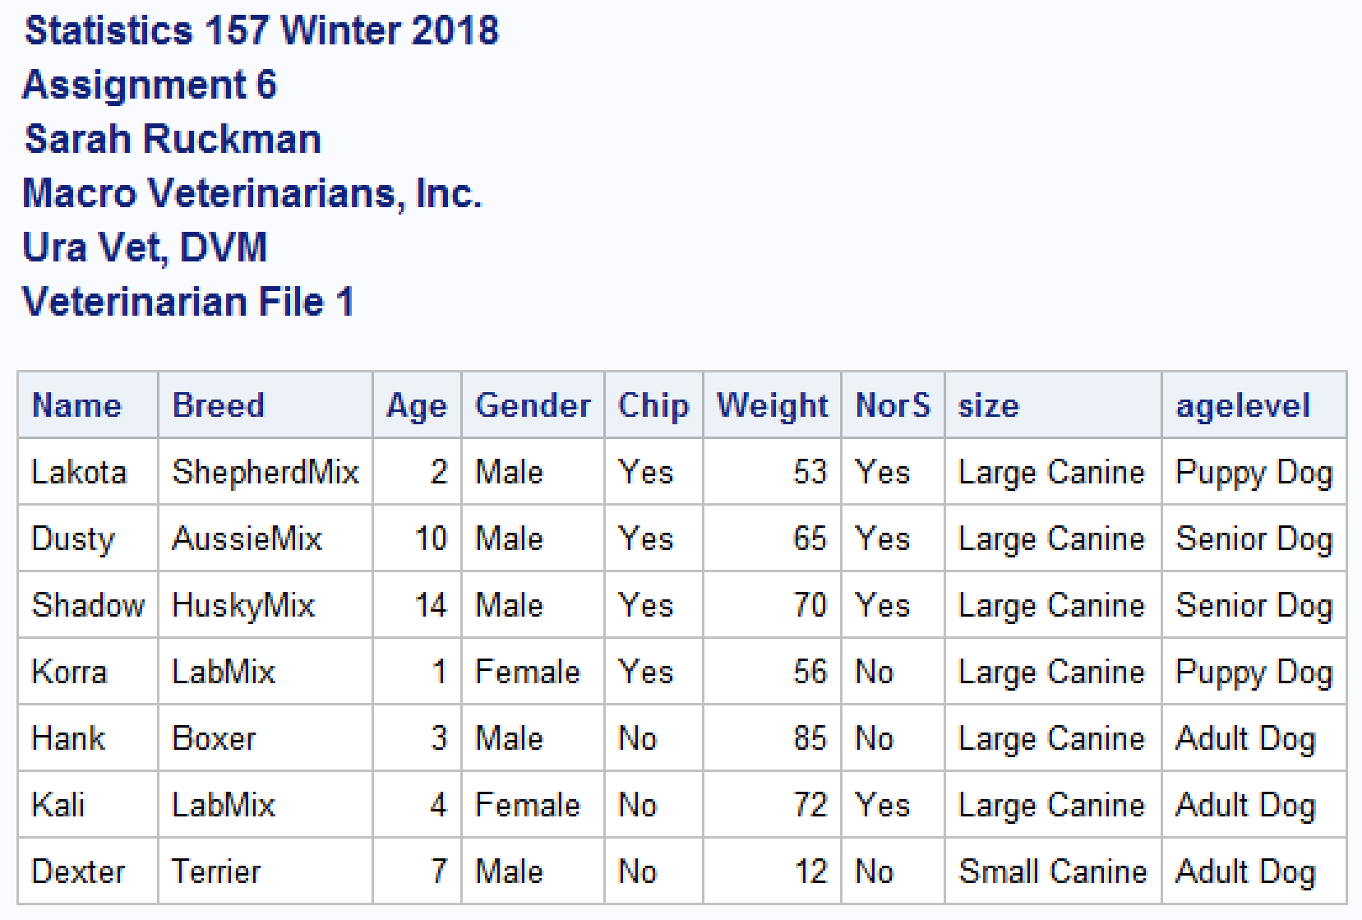

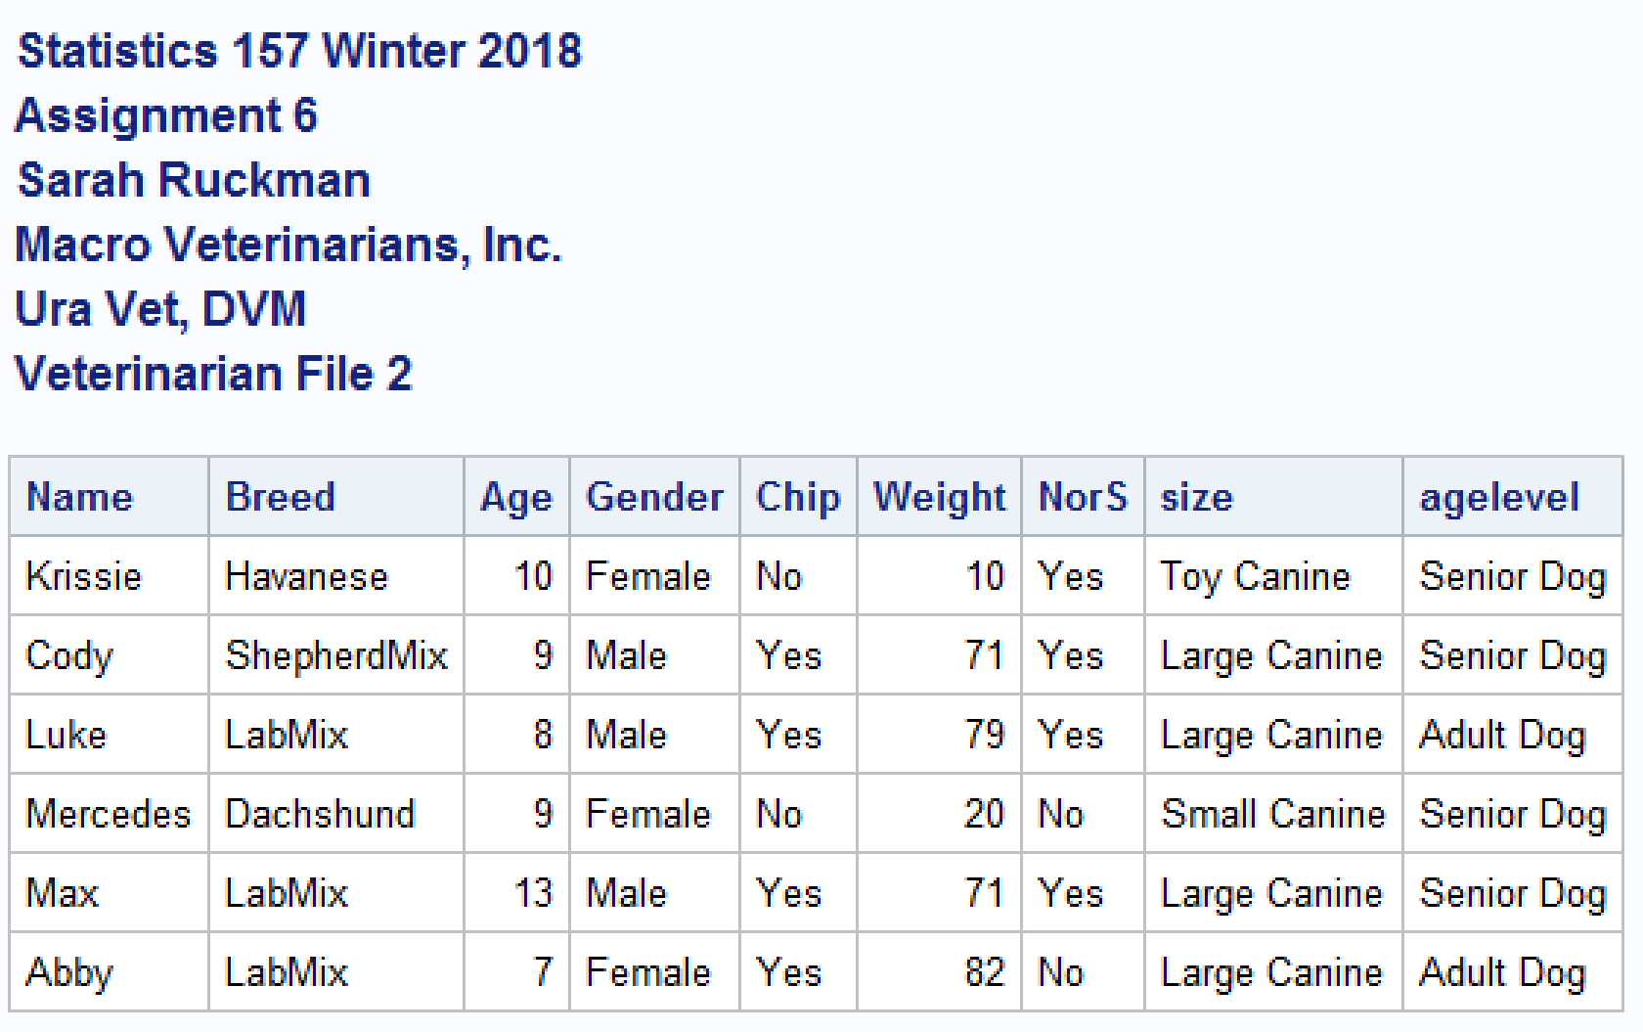

1. NEW (5 pts) Write a SAS macro called univar1 (to be invoked inside the indata macro) which will print the sample size (n), mean, median and standard deviation for each data set for any specified variable. The variable should be sent across as a parameter! Test your macro using the variable weight. (NOTE: You may have to change the number of parameters in the indata1 macro.)

**SAS Code:**

**Added prior to indata1 macro:**

/********************************************************************

macro univar1 to be used to find descriptive statistics for each data

file using proc means and specifying mean, sample size, median, and

standard deviation

Variables:

varname name of variable to be specified in indata1 macro

*********************************************************************/

**%macro** univar1(varname);

proc means n mean median stddev;

%*Use a var statement to input the variable of interest;

var &varname;

%*Close the univar1 macro;

**%mend** univar1;

**Added inside indata1 macro after %ageclass: Including a new parameter varname in the indata1 parameter list varname:**

%*Invoke the macro univar1 and have the parameter varname to add any variable later;

%***univar1***(&varname);

**Output:**

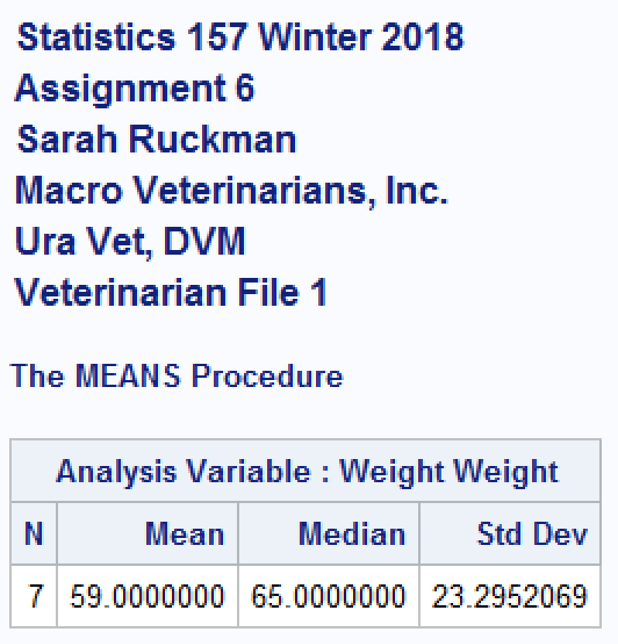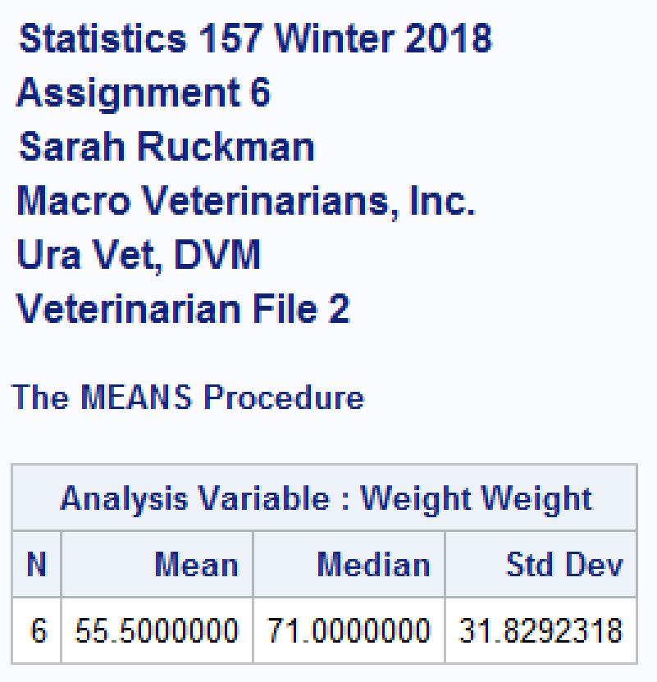

1. Create a new temporary SAS dataset, called combine1 that contains and prints all the data. Be sure you modify title6 to reflect that this is the Combined Data. Make this generic enough to combine any number of data sets, not just two. (Hint: Make use of a namelst macro!) (6 pts)

**SAS Code:**

/*

*******************************************************************

Macro namelst macro designed to generate a list of sequential data

file names where the name and the number of the files are

specified by the user

Variable specification:

name name of the sequential data files to be generated in the list

number number of the data files names to be generated in the list

*******************************************************************

*/

**%macro** namelst(name,number);

%do n = **1** %to &number;

&name&n

%end;

**%mend** namelst;

/*************************************************************************

macro combine1 macro to combine all data files

Variable Specification:

basename base name of existing SAS dataset

number number of files to combine

*************************************************************************/

**%macro** combine1(basename,number);

%*Create new temporary SAS dataset called combine1;

data combine1;

%*Use the set command to concatenate all of the files;

set %***namelst***(&basename,&number);

%*Classify dogs according to size;

%***sizing***;

%*Classify dogs according to age;

%***ageclass***;

%*Create new title 6;

title6 'Veterinarian File Combined Data';

%*Print as check;

proc print;

%*Close the macro;

**%mend** combine1;

/*Execute the macro combined

Format %combined(basename,number)*/

%***combine1***(dog,**2**);

**Output:**

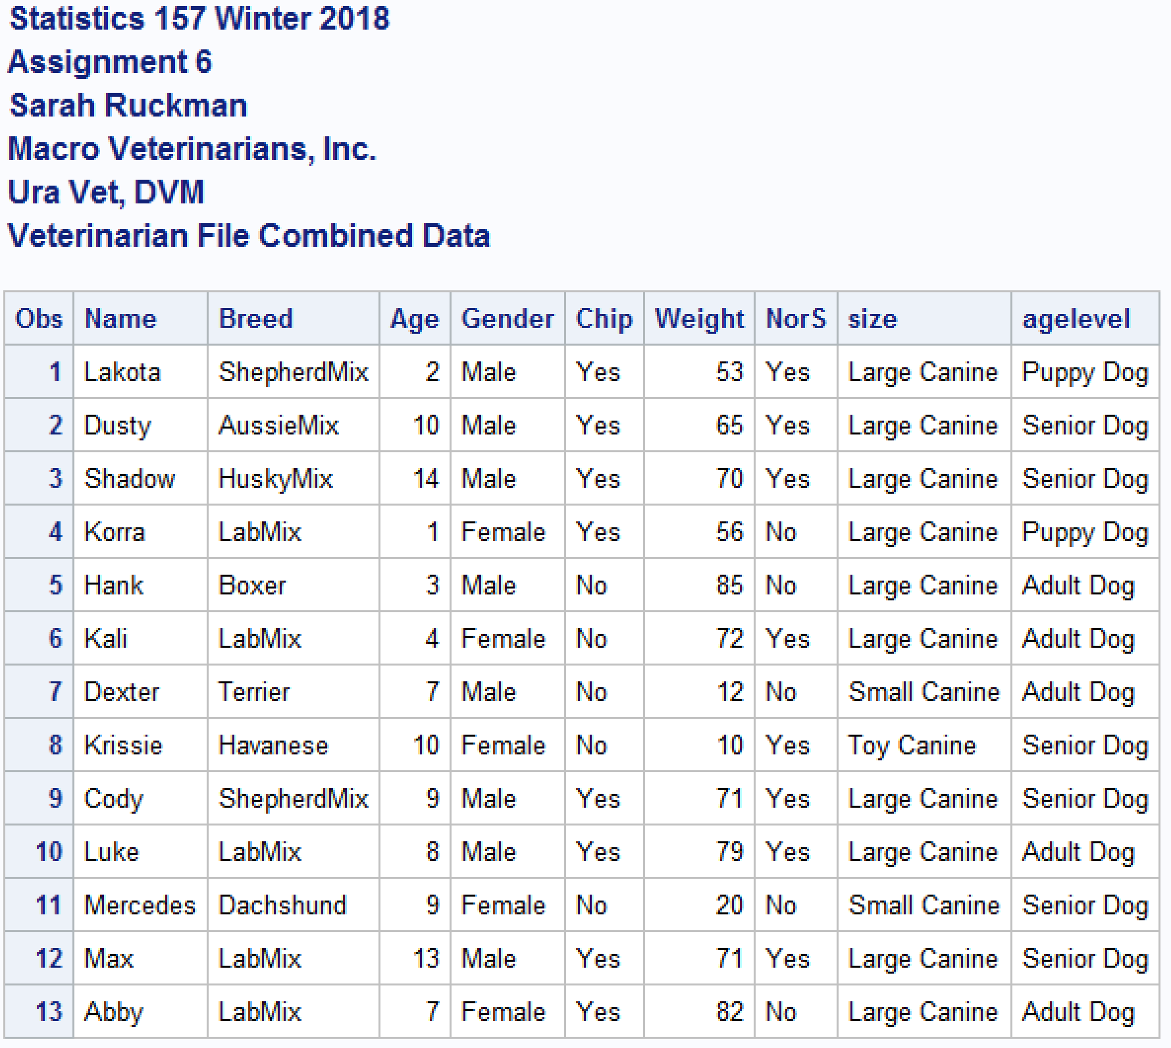

**Complete SAS Code:**

/*Set up format for the output*/

options ls = **78** ps = **55** nodate nonumber nocenter mtrace mlogic mprint;

ods graphics off;

/*

*******************************************************************

Macro namelst macro designed to generate a list of sequential data

file names where the name and the number of the files are

specified by the user

Variable specification:

name name of the sequential data files to be generated in the list

number number of the data files names to be generated in the list

*******************************************************************

*/

**%macro** namelst(name,number);

%do n = **1** %to &number;

&name&n

%end;

**%mend** namelst;

/*

*******************************************************************

macro heading1 macro to generate titles

Parameters

what parameter to identify what object

number1 number of the object

quarter1 quarter and year

filenum which data file (1 or 2)

*******************************************************************

*/

**%macro** heading1(what,number1,quarter1,filenum);

title1 "Statistics 157 &quarter1";

title2 "&what &number1";

title3 "Sarah Ruckman";

title4 "Macro Veterinarians, Inc.";

title5 "Ura Vet, DVM";

title6 "Veterinarian File &filenum";

%*Close the macro;

**%mend** heading1;

/********************************************************************

Macro sizing to classify each dog according to size

Variable specifications:

size name of size variable

********************************************************************/

**%macro** ***sizing***;

%* Use if then else structure to classify size;

if Weight <= **10** then size = 'Toy Canine ';

else if **10** < Weight <= **25** then size = 'Small Canine ';

else if **25** < Weight <= **50** then size = 'Medium Canine';

else if **50** < Weight <= **90** then size = 'Large Canine ';

else size = 'Giant Canine ';

%*Close the macro;

**%mend** sizing;

/********************************************************************

Macro ageclass macro to classify an animal according to age

Variable Specification:

agelevel name of age class variable

********************************************************************/

**%macro** ***ageclass***;

%* Use if then else structure to classify age;

if age <= **2** then agelevel = 'Puppy Dog ';

else if **2** < age <= **8** then agelevel = 'Adult Dog ';

else agelevel = 'Senior Dog';

%*Close the macro;

**%mend** ageclass;

/********************************************************************

macro univar1 to be used to find descriptive statistics for each data

file using proc means and specifying mean, sample size, median, and

standard deviation

Variables:

varname name of variable to be specified in indata1 macro

*********************************************************************/

**%macro** univar1(varname);

proc means n mean median stddev;

%*Use a var statement to input the variable of interest;

var &varname;

%*Close the univar1 macro;

**%mend** univar1;

/* ******************************************************************

macro importing

USAGE: to read in Excel files

Variables:

start sheet number to start

stop sheet number to stop

name1 base name of the worksheets

name2 name to add on for new SAS dataset

filename name and path to Excel file to be read in

varname the variable name to use to find descriptive statistics

******************************************************************* */

**%macro** indata1(start,stop,name1,name2,filename,varname);

%*Setup macro do loop to read in series of worksheets;

%do i = &start %to &stop;

%* Use proc import to import the excel file;

PROC IMPORT OUT = WORK.&name1&i

DATAFILE= "&filename&i..xls"

DBMS=xls REPLACE;

SHEET="&name1&i";

GETNAMES=YES;

%*Create new SAS temporary dataset;

data &name1&i&name2;

%* Format %heading1(what,number1,quarter1,&i);

%***heading1***(Assignment,**6**,Winter **2018**,&i);

%*Use set command to get information from output file;

set &name1&i;

%* Classify dogs according to size;

%***sizing***;

%*CLassify dogs according to age;

%***ageclass***;

%*Invoke the macro univar1 and have the parameter varname to add any variable later;

%***univar1***(&varname);

%*Print the data as check;

proc print noobs;

%*Close the marco do loop;

%end;

%*Close the macro;

**%mend** indata1;

/*************************************************************************

macro combine1 macro to combine all data files

Variable Specification:

basename base name of existing SAS dataset

number number of files to combine

*************************************************************************/

**%macro** combine1(basename,number);

%*Create new temporary SAS dataset called combine1;

data combine1;

%*Use the set command to concatenate all of the files;

set %***namelst***(&basename,&number);

%*Classify dogs according to size;

%***sizing***;

%*Classify dogs according to age;

%***ageclass***;

%*Create new title 6;

title6 'Veterinarian File Combined Data';

%*Print as check;

proc print;

%*Close the macro;

**%mend** combine1;

/*Execute the macro

Format %indata1(start,stop,name1,name2,filename_including_path,varname)

Be sure you change the path to your file*/

%***indata1***(**1**,**2**,dog,b,C:\Users\sarah\Downloads\dogs_w18,weight);

/*Execute the macro combined

Format %combined(basename,number)*/

%***combine1***(dog,**2**);

**run**;

**quit**;